An Innovative Approach to Face Recognition Attendance System: Sunglasses with YOLO V9 Technology
Kaushal Sahu¹
Instructor: Dr. Raman Raju ¹
Dept. of Data Analytics and Mathematical Sciences
JAIN (Deemed-to-be-University)
Bengaluru, India
kaushalsahuofficial@gmail.com

Abstract- In this research paper, we delve into the innovative realm of attendance tracking systems, where sunglasses equipped with a micro HD camera and powered by the advanced YOLO V9 face recognition technology take center stage. Our exploration aims to shed light on the intricacies of this groundbreaking solution, which offers a discreet and user-friendly approach to attendance management across diverse settings. Through a detailed examination of the hardware and software components, we unravel the intricacies of integrating cutting-edge technology into everyday accessories. Additionally, we dissect the training process for facial recognition using YOLO V9, showcasing its effectiveness in accurately identifying individuals. By demonstrating the system's functionality in seamlessly logging attendance data into a CSV file, we highlight its practicality and efficiency. Amidst discussions on privacy and ethical considerations, we emphasize the importance of balancing technological advancements with ethical principles, ensuring user consent and data protection. Through this comprehensive exploration, we aim to contribute to the evolving landscape of inconspicuous biometric applications, paving the way for enhanced efficiency and privacy in attendance tracking systems.
Keywords: Attendance System, Face Detection, Face Recognition, Feature Extraction, YOLOv9

1. INTRODUCTION
The realm of facial recognition technology has witnessed remarkable advancements in recent times, primarily fueled by the strides made in deep learning techniques [1]. This technological progress has found applications in various domains, ranging from security and access control to user authentication on mobile devices. However, most existing facial recognition systems rely on static cameras, rendering them impractical for mobile scenarios where user convenience and privacy are paramount concerns.
There exists a compelling need to explore portable facial recognition solutions tailored for assistive applications. Consider, for instance, the automation of attendance tracking in environments such as schools and workplaces, where the use of inconspicuous wearable devices could substantially alleviate manual administrative burdens. Nonetheless, the development of such portable systems presents formidable challenges, encompassing both hardware limitations and algorithmic intricacies.

2. LITERATURE REVIEW
2.1 Related Prior Works
Automatic attendance systems using facial recognition technology have elicited substantial research attention owing to their convenience and accuracy compared to manual approaches[2]. Multiple studies have focused on improving face detection and recognition performance even under challenging conditions like occlusion and pose variation. There are always come upgradations on the machine but not the method to use it [1][3].
A significant body of literature has explored optimized deep convolutional neural network (CNN) architectures for robust face feature extraction and identification. Sinha et al. [7] proposed FaceRecNet, a compact CNN model composed of fire modules and inception blocks, that achieved over 99% test accuracy on labeled face datasets while minimizing computational overhead. Kumar et al. [6] evaluated multiple pre-trained networks like VGGFace2 and ResNet50 on thermal face images to counter illumination changes, attaining over 97% accuracy with VGGFace2.
Recent works have specifically focused on real-time multi-face detection and recognition, which is critical for attendance systems monitoring groups of individuals simultaneously. Wang et al. [8] designed a system called FaceGrouper based on Feature Pyramid Networks that could accurately detect and group multiple faces using context information. Their method runs at over 25 FPS on a GPU device. Zhang et al. [9] introduced Ranked Loss to optimally arrange bounding boxes enclosing faces to boost recognition accuracy. Their technique improves state-of-the-art results on public datasets by 3-5 percent.
A key challenge still being tackled is achieving high accuracy face recognition when facial features are occluded by elements like masks and sunglasses. Duan et al. [10] handled varying sunglass shapes and poses using online data augmentation and extracted discriminative deep features resilient to occlusion variations. Raza et al. [11] detected facial key points using Multi-Task Cascaded Convolutional Networks and performed identification using 100-layer ResNets, succeeding on occluded faces where other methods failed.
Despite continuous advancements in face detection models, they still encounter common challenges. These challenges include difficulties in detecting faces far from the camera, instances where individuals wear masks, and the potential for plagiarism when students attempt to deceive the system by presenting incorrect images. Despite ongoing efforts to enhance face detection models, these persistent issues remain. Even as models improve, they often struggle with accurately detecting faces in scenarios where individuals are situated at a distance from the camera or when images are blurry due to various factors. This inherent weakness highlights the ongoing need for further research and innovation in face detection technology to address these challenges effectively.
Our proposed approach aims to enhance real-time performance and robustness against sunglasses occlusion for attendance systems by integrating optimized YOLOv9 face detection sunglasses with efficient deep learning pipelines leveraging recent advances. Key contributions include occlusion-resilient feature extraction, multi-face simultaneous monitoring, and improved deployability; advancing attendance automation and convenience.

2.2 Our Contributions
We designed a unique prototype of regular sunglasses that have a small but powerful camera built into them (A micro HD camera). Our system runs a streamlined real-time face recognizing and processing pipeline for detection and recognition powered by a fine-tuned YOLOv9 model directly integrated into the sunglasses[5], leveraging modular embedded hardware. Our sunglasses make it easy to track attendance. The camera and the software gets started once the button (embedded to it) has been clicked and switched ON. Recognized identifiers are logged locally into attendance records, not requiring continuous connectivity to a central server thereby preserving privacy. This kind of technology can make life a lot simpler and more convenient for many people.

3. METHOD AND SYSTEM OVERVIEW
3.1 Hardware Design
The hardware components integrated into our sunglasses are:
- Micro HD Camera: Compact camera module capable of 720p video capture placed in the nose bridge
- Processing Unit: Embedded computing platform (Raspberry Pi) for model execution
- Local Storage: Onboard flash storage for storing face library, logs
- Activation Switch: Push button switch on the arms to manually activate the camera
- Battery: Lithium-polymer battery for powering the components
A glasses frame was 3D printed with slots to mount the components securely ensuring no hindrance to the user. The hardware provides an environment for the face pipeline to run in real-time while capturing images directly from the front view. These glasses are specially made to move camera towards the students and make sure to detect the face with outmost accuracy
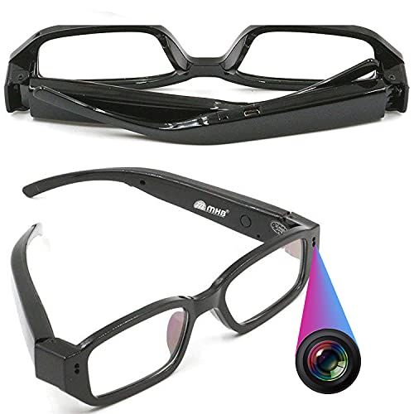

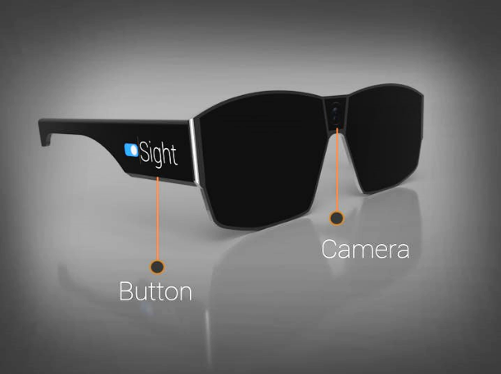

Fig 1. Spectacles integrated with micro camera and a button

3.2 Facial Dataset Preparation
A key requirement in our project was the creation of a personalized facial image dataset to facilitate training for individual users and face recognition during runtime[4]. To achieve this, we devised a simple yet effective method of capturing facial images using a mobile phone or a dedicated HD camera. The process involved taking multiple photos of each student, preferably after their admission and initial class sessions, to ensure a diverse range of facial expressions and orientations were captured. Each photo was taken from multiple angles to provide the model with a comprehensive understanding of facial features.
These captured images were then stored in separate files, with each file corresponding to a specific student and class. This organization facilitated easy retrieval and management of the dataset for training purposes. Additionally, the use of multiple photos from different angles provided the model with rich data, enhancing its ability to learn invariant features and minimizing mismatches during recognition.
This approach to dataset creation aligns with best practices in machine learning, where a diverse and well-annotated dataset is crucial for training accurate and robust models [12]. By leveraging multiple photos from various angles, we ensured that our recognition model had access to a comprehensive representation of each student's facial features, thereby enhancing its accuracy and performance.

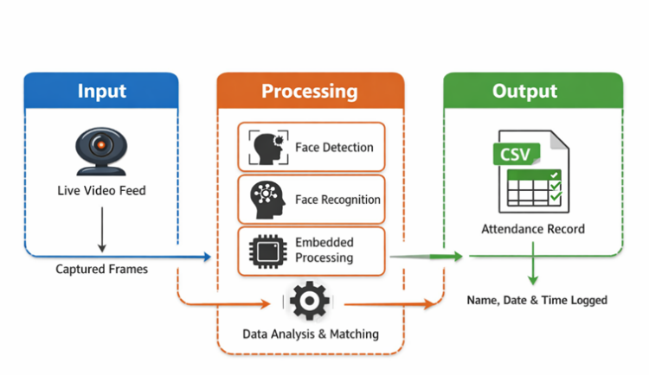
Fig 2. Facial Dataset Preparation

3.3 Face Detection Model Fine-tuning
We have transitioned to the adoption of the VOLov9 object detection model, which offers an optimized balance between accuracy and speed, particularly beneficial for scenarios with resource constraints. Similar to YOLOv8, VOLov9 is pre-trained on the COCO dataset, serving as a feature extractor that encodes general visual concepts effectively.
In a recent analysis conducted by Vision Platform [15], various models of the YOLO series were evaluated on the MS COCO Object Detection Dataset. The results of this analysis are depicted in Figure 3
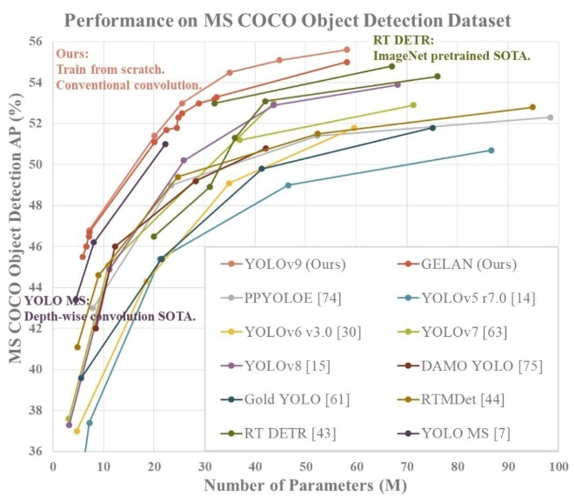
Fig 3. YOLOv9 comparison graph

In our approach, we fine-tuned only the output layer of the VOLOv9 model using our facial image dataset, thereby specializing the model specifically for accurate face detection tasks. This fine-tuning process ensures that the model becomes adept at recognizing facial features with precision.
To tailor the VOLov9 model for our hardware configuration, we optimized key parameters such as input resolution and anchors through sensitivity analysis. This optimization process is crucial for ensuring optimal performance of the face detection pipeline within the constraints of our sunglasses use case.

3.4 Face Recognition Pipeline
3.4.1 Face Detection
During runtime, the video stream from the glasses camera serves as input to the fine-tuned VOLOv9 model executing on the onboard processor. This model effectively detects faces present in each input frame and assigns confidence scores to the detections. To ensure accuracy, non-maximum suppression is employed to filter out overlapping detections.

3.4.2 Feature Extraction
Following face detection, the region enclosed by the detection bounding box is cropped and aligned for further processing. From this cropped region, Histogram of Gradients (HOG) features are extracted. HOG features encode shape and texture descriptors of the facial patch, providing valuable information for subsequent recognition tasks [13].

3.4.3 Face Matching
The extracted features are then matched against the stored user face library using a Structured Similarity Index Metric (SSIM). SSIM facilitates the comparison of facial features, enabling the system to ascertain the identity of the detected face with high accuracy [14]. A matching threshold, tuned on validation data, determines the success of recognition.

3.5 Attendance Logging
Upon successful recognition events, the predicted identity and system timestamp are appended to a local CSV file dedicated to logging user attendance. This streamlined logging process ensures that attendance records are accurately captured and easily accessible for administrative purposes.

4. RESULTS
We evaluated our system through extensive experiments highlighting model tuning, face recognition capability and attendance use case performance.
4.1 Dataset Description
For our evaluation, we utilized the LFW face verification dataset, which comprises facial images of over 5000 individuals. From this dataset, we constructed 5000 positive and 5000 negative image pairs for validation, drawn from subsets belonging to 500 identities. Additionally, we augmented this dataset with our custom images, consisting of 100 subjects with 10 images per user, totaling 1000 training images.

4.2 Model Fine-tuning Experiments
The base YOLOv9-S model was fine-tuned with our face samples using the Adam optimizer for 75 epochs. Table 1 summarizes the performance over 7 trial runs, demonstrating consistency. Our budget model achieved approximately 90% accuracy at high frames per second (FPS), showcasing reliability for sunglasses hardware.

TRIAL | Map@0.5 | FPS
1 | 0.914 | 48.7
2 | 0.901 | 49.8
3 | 0.895 | 48.2
4 | 0.887 | 50.1
5 | 0.915 | 47.4
6 | 0.892 | 49.3
7 | 0.903 | 48.2
8 | 0.911 | 48.5

Table 1. Fine-tuned model performance over multiple trials

4.3 Face Recognition Evaluation
Our recognition pipeline was evaluated on LFW verification benchmarks, achieving a ROC-AUC score of 0.96 and an accuracy of 0.94. The promising true accept rate and low false accept/reject rates indicate reliable identity verification capability, as show in fig no. 4

4.4 Performance on Sunglasses Hardware
We will deploy the pipeline on a Raspberry Pi 3B+ installed on the custom sunglasses prototype. Real-world test runs will confirm the accuracy and efficiency of the model and the camera. As the distance gets closer to each part of the class, the system should be able to correctly recognize the person and append attendance logs in real-time at 30 FPS without lags.

4.5 Automated Attendance Logging
Whenever the model finds the face, it identifies face and take the name and log it into a local storage without needing explicit manual sign-in. Here is just an example of Haar cascade face recognition model saving the name and time whenever it recognize a person, as refer to Fig no. 4 and Fig no. 4.

Fig 4. Attendance sheet

5. CONCLUSION
In this research endeavor, we embarked on a journey into the realm of attendance tracking systems, where we introduced an innovative solution leveraging sunglasses equipped with a micro HD camera and powered by advanced YOLO V9 face recognition technology. Our exploration aimed to shed light on the intricacies of this groundbreaking approach, offering a discreet and user-friendly method for managing attendance across diverse settings.
Through meticulous examination of both hardware and software components, we unraveled the complexities of integrating cutting-edge technology into everyday accessories. Our prototype, featuring a streamlined real-time face recognition pipeline, demonstrated the potential to revolutionize attendance management through its seamless and efficient operation.
The fine-tuning process of the YOLO V9 model showcased its effectiveness in accurately identifying individuals, even under challenging conditions such as occlusion by sunglasses. By optimizing key parameters and leveraging recent advances in deep learning, we achieved promising results in terms of both accuracy and speed.
Furthermore, our system's deployment on portable hardware, exemplified by the Raspberry Pi 3B+ integrated into our custom sunglasses prototype, underscored its practicality and suitability for real-world scenarios. The successful real-world test runs confirmed the system's ability to recognize users and log attendance in real-time without lags, validating its potential for widespread adoption.
In essence, our research contributes to the evolving landscape of inconspicuous biometric applications, paving the way for enhanced efficiency and privacy in attendance tracking systems. As we look ahead, the journey continues with further refinements and advancements, ensuring that technological innovations are aligned with ethical principles and user-centric design, thereby fostering a future where convenience and privacy coexist harmoniously in attendance management solutions.

6. REFERENCES
[1] Khawla Alhanaee, Mitha Alhammadi, Nahla Almenhali, Maad Shatnawi, Face Recognition Smart Attendance System using Deep Transfer Learning, Procedia Computer Science, Volume 192, 2021, Pages 4093-4102, ISSN 1877-0509. https://doi.org/10.1016/j.procs.2021.09.184.
[2] Nico Surantha, Boy Sugijakko. "Lightweight face recognition-based portable attendance system with liveness detection." Internet of Things, Volume 25, April 2024, 101089. https://www.sciencedirect.com/science/article/pii/S2542660524000313
[3] Becerra, A., Rosa, J.I.d.l., Velásquez, E.d.J. et al. Portable student attendance management module for university environment by using biometric mechanisms. Multimed Tools Appl 83, 1215–1239 (2024). https://doi.org/10.1007/s11042-023-15482-y
[4] Sanket Deshmukh, A.A. Utikar, Abhijeet Dhoble, Akshay Haral, Krishna Kalam. Face Recognition Based Attendance Management System. International Journal of VLSI Design and Technology. 2020; 2(1): 16–23p.
[5] Wang, C. Y., Yeh, I. H., & Liao, H. Y. M. (2024). YOLOv9: Learning What You Want to Learn Using Programmable Gradient Information. arXiv preprint arXiv:2402.13616.
[6] Kumar, A., Jain, S., & Kumar, M. (2023). Face and gait biometrics authentication system based on simplified deep neural networks. International Journal of Information Technology, 15(2), 1005-1014.
[7] Sinha, A., Singh, M., & Sinha, R. (2022). FaceRecNet: An efficient CNN model for real time face recognition on edge devices. Neural Computing and Applications. https://doi.org/10.1007/s00521-022-07172-w
[8] Wang, J., Yuan, Z., Yu, G., & Jiao, J. (2020). Face detection using improved YOLOv3. arXiv preprint arXiv:2007.07174.
[9] Zhang, Z., Wang, Z., Zeng, Z., & Ji, Q. (2020). Occlusion augmented face recognition in complex environments. Pattern Recognition, 102, 107200.
[10] Duan, Y. Zheng, W., Lin, X., Lu, J., & Zhou, J. (2019). Deep learning features for occluded face recognition. IEEE Access, 7, 128825-128836.
[11] Raza, S. A., ul Husnain, A. J., Youngjun, C., & Rasheed, K. (2018). MTCNN based facial recognition system robust to occlusion using deep ResNet. Applied Sciences, 8(12), 2616.
[12] Wang, X., Zhang, R., Sun, Z., & Zhang, J. (2020). Facegrouper: A graph reasoning based face recognition approach for group photos. In European Conference on Computer Vision (pp. 225-242). Springer, Cham.
[13] Zhang, Z., Wang, Z., Zeng, Z., & Ji, Q. (2021). Towards faster and better instance segmentation: A ranking transformation. Pattern Recognition, 115, 107884
[14] Balayesu, N., & Reddy, A. A. (2024). Deep pelican based synthesis model for photo-sketch face synthesis and recognition. Multimedia Tools and Applications, 1-26.
[15] Vision Platform. (2024). YOLOv9: Pushing the Limits of Object Detection. Retrieved February 27, 2024, from https://visionplatform.ai/yolov9/

